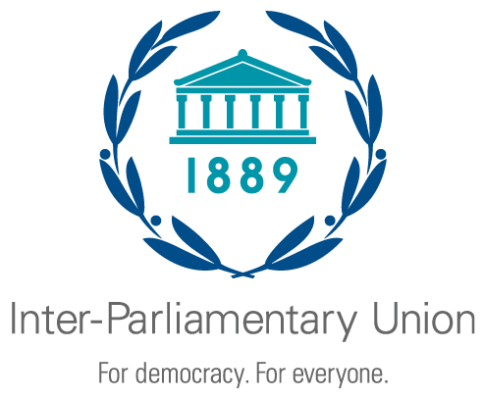
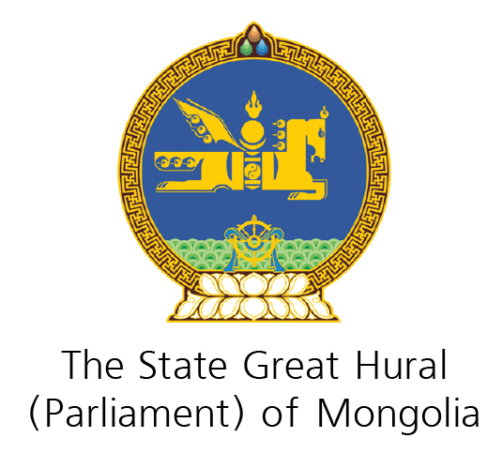
Second Regional Seminar for the Asia-Pacific Region Parliaments
on Achieving the Sustainable Development Goals

Ulaanbaatar (Mongolia), 27-28 May 2019

Organized jointly by the Inter-Parliamentary Union and the State Great Hural of Mongolia

GENERAL INFORMATION

SEMINAR VENUE AND DATE

The seminar will be held from 27 to 28 May 2019 at the State Palace in Ulaanbaatar, Mongolia. Badges and seminar documents should be collected at the State Palace. Delegates will be able to access the seminar areas after collecting their badges.

Address of State Palace:
Sukhbaatar district, Sukhbaatar square 1
Ulaanbaatar 14201, Mongolia

PARTICIPATION

The seminar is open to the parliaments of the following Asia Pacific countries: Afghanistan, Australia, Bangladesh, Bhutan, Cambodia, Canada, China, Democratic People's Republic of Korea, Fiji, India, Indonesia, Iran (Islamic Republic of), Japan, Lao People's Democratic Republic, Malaysia, Maldives, Micronesia (Federated States of), Mongolia, Myanmar, Nepal, New Zealand, Pakistan, Palau, Papua New Guinea, Philippines, Republic of Korea, Samoa, Singapore, Sri Lanka, Thailand, Timor-Leste, Tonga and Viet Nam.
The seminar is also open to the following non-IPU members: Brunei, Kiribati, Marshall Islands, Nauru, Solomon Islands, Tuvalu, and Vanuatu.
Delegations should be gender-balanced and reflect the political representation of their respective parliaments. It is recommended that delegates should be those working directly on sustainable development issues in their respective parliaments.

ORGANIZATION OF PROCEEDINGS

In keeping with IPU practice, all participants will have equal speaking rights. To make the discussions as fruitful and enriching as possible, the following rules will apply:

- After the resource persons have introduced an agenda item, the floor will be opened to participants for questions and comments.

- Experience has shown that this kind of meeting does not lend itself to the reading out of prepared statements. Subject to arrangements that the Chair may make to suit the circumstances, oral contributions may not exceed three minutes. Participants may speak several times on each item, particularly to respond to other statements.

DOCUMENTS

Where possible, the IPU Secretariat will make available any presentation on the topics discussed on the IPU website.

Participants wishing to distribute relevant documentation to their colleagues will be required to provide it in sufficient quantities and place it on a designated table.

WORKING LANGUAGE

The working languages will be English, Mongolian.

Delegations wishing to use interpretation facilities should inform the organizers no later than 15 April 2019. Additional interpretation booths are available and will be made available on a first-come-first-serve-basis.

REGISTRATION

Participants should complete and submit the enclosed registration forms as soon as possible, and no later than 15 May 2019, to:

State Great Hural | With copy to:
State Palace  ULAANBAATAR  Mongolia | Inter-Parliamentary Union
 | Chemin du Pommier 5,
Secretariat of the Seminar: | C.P. 330, 1218 Le Grand-Saconnex
Ms. Judag Bayarmaa  Secretary of the Mongolian  Inter-Parliamentary Group | Geneva, Switzerland
Tel: +976-51-261758/262866 | Tel: +41 22 919 4150
Fax: +976-11-322866 | Fax: +41 22 919 4160
E-mail: foreign.relations@parliament.mn
bayarmaaj@parliament.mn
Cc to: Mrs. Sh.Narantuya
Head of the Foreign Relations Department, the Secretariat of the State Great Hural /Parliament/ of Mongolia

Tel: +976-51-262150
Fax: +976-11-322866
E-mail: narantuyash@parliament.mn

