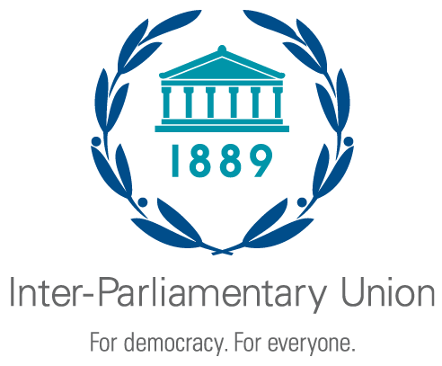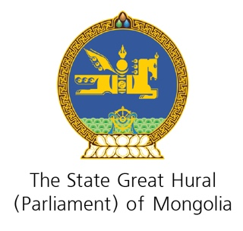

Second Regional Seminar for the Asia-Pacific Region Parliaments
on Achieving the Sustainable Development Goals

Ulaanbaatar (Mongolia), 27-28 May 2019

Organized jointly by the Inter-Parliamentary Union
and the State Great Hural of Mongolia

CONCEPT NOTE

The Sustainable Development Goals (SDGs) were adopted in September 2015 by the United Nations General Assembly as part of the 2030 Agenda for Sustainable Development. There are 17 goals in total, comprised of 169 targets. The SDGs are intended to focus and coordinate national policies towards a common vision for humanity. They are seen as the principal starting point for providing a better-quality social and natural environment, where all citizens are free to fully realize their own human development. The SDGs are a groundbreaking and comprehensive policy framework that has the potential to drive the world towards positive change while making sure that no one is left behind.
The IPU Member Parliaments have on many occasions reiterated their commitment to do their utmost to make sure that the SDGs are effectively implemented. Under the auspices of the IPU, parliaments have pledged to translate the SDGs into enforceable domestic law, hold governments accountable and align budgets with national sustainable development plans. They have highlighted the need for parliaments and decision-making processes to be strengthened so they are fit for the purpose of realizing this commitment.
In May 2017, the parliaments of the Asia-Pacific region met for the first time in Ho Chi Minh City (Viet Nam) to discuss concrete steps that would help implement the SDGs in their countries and the region. On that occasion parliaments adopted an outcome document that called for legislatures in all countries to play an active role in domesticating the SDGs and their targets. They urged parliaments to take action in a number of key areas, including gender equality, climate change, and sectoral, regional and international cooperation on the SDGs.
This second regional seminar will give parliaments the opportunity to build on the recommendations identified during the previous seminar and discuss the crucial role that education plays in achieving the SDGs. Education is crucial to breaking the cycle of poverty and helping individuals and communities to improve their health by increasing their knowledge or influencing their attitudes. The seminar will put particular emphasis on how parliaments and parliamentarians could promote “environmental literacy” and increase awareness on climate change and disaster risk reduction. The meeting will also highlight the paramount importance of ensuring that socially and economically marginalized populations are not left behind.
Format, objectives and expected outcomes of the seminar
The seminar will be made up of a series of plenary panel discussions led by relevant experts. These debates will be further pursued through more focused roundtable discussions. The overall aim of the seminar is to have parliaments from the Asia-Pacific region share experiences, and engage in comprehensive discussions on the most efficient ways to institutionalize the SDGs and ensure that nobody is left behind. The seminar will serve as a platform to allow participants get acquainted with good practices in developing effective parliamentary strategies for SDG implementation.
The seminar will be followed by a field visit organized by the Parliament of Mongolia.
It is expected that the seminar will conclude with an outcome document outlining key issues discussed and forward-looking recommendations to parliaments to effectively advance the implementation of the SDGs at the national and regional levels.

